QUESTION 3 Notes

Question 3 A
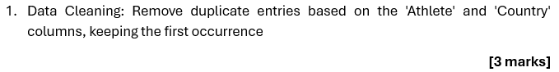
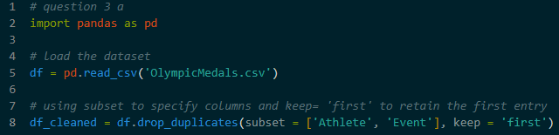
- Action – Using df.drop_duplicates() to find rows where both the Athlete and the Country are identical
- Using keep=’first’ to ensure that only the first recorded entry for an athlete remains in the dataset, while all subsequent copies are deleted
- This ensures that each athlete Is counted only once in the final analysis

Question 3 B
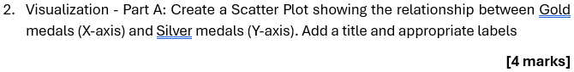
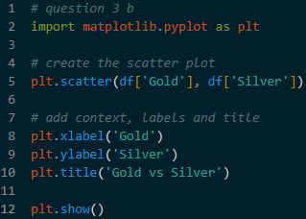
- A scatter plot is used to observe the relationship between two different numerical variables
- The axis selection : Placing Gold medals on the horizontal axis (x) and Silver medals on the vertical axis (y)
- By looking at the distribution of dots, we can see if athletes who win many gold medals also tend to win many silver medals
- By adding a title, an x-label, and a y-label to ensure any viewer can understand the units of measurement without prior knowledge of the code

Question 3 C
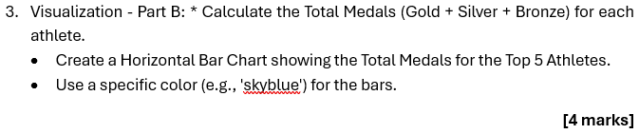
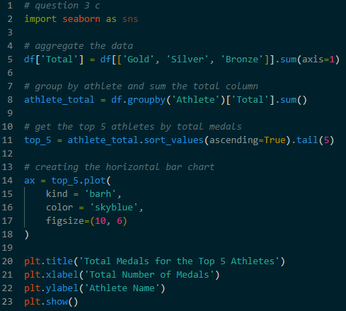
- Calculations : Create a new column called Total by adding the values of the Gold, Silver and Bronze columns for every row
- Aggregation : Grouping the data by Athlete and sum the Total column
- Selection : Sort the results in ascending order and use .tail(5) to pick the five athleters with the highest medal counts
- Using kind=’barh’ to create a horizontal chart

Question 3 D
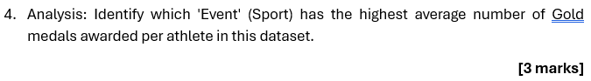
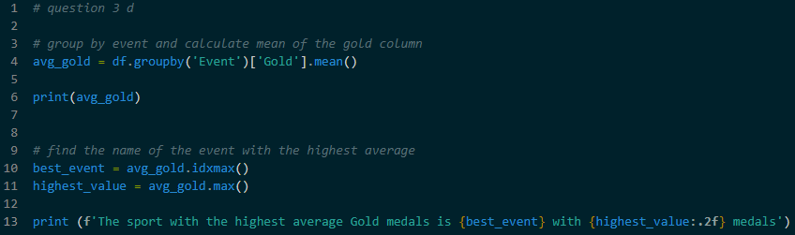
This script identifies which sport has the highest average reward per participant
- By grouping all records by the Event column
- The Calculation : Calculating the mean(avg) of the Gold column for each sport group
- Using the .idxmax() function to find the result. This function automatically scans the list of averages and returns the name of the sport associated with the highest number
- Using .max() to print the actual numerical average for that sport

